Intelligence never comes when we know all the answers

Rashid Mehmood
laravelprodev@gmail.com

Abstract
Nowdays people are overwhelmed by Large Language Models LLMs. They seems to be quick, accurate, creative and reliable in most cases, because of these unfathomed potential people are very much hopeful that AGI is just few years away. LLMs are just pattern recognizers contained in the set of training data, they cannot think outside the boundaries of their memorized patterns. All the data generated by LLMs called as synthetic data itself cannot cross the boundaries of training data, its just new patterns and combinations of base training data or synthetic data. Creativity, knowledge, ideas and information abilities of LLMs cannot cross the boundaries of digital human knowledge fed to them as training data on the other hand human intelligence is not bound by these boundaries. Every new model of LLM comes with new tricks and smarter techniques to get required memory patterns from very huge database. At the end of the day LLMs can only discover new patterns in existing data which seems to us as intelligence at some level but they cannot invent a novel idea from this huge data which ability is definitely the key to the future success for AI and whole mankind. They also lack test-time fine-tuning when they come across novel situations. Intelligence basically is not about knowing all the answers its about asking questions and then finding answers of those questions and inventing new ideas, tools and systems during that process. All the human development in science is basically the answers of the questions previously asked or the byproduct of that question answer session. Human history is full of that, from the invention of hand axe to the invention of nuclear weapons, from the invention of wheel to bullet trains, mechanical calculator to quantum computers etc. One of the most recent question is about how human mind works and all the development in neuroscience and artificial intelligence is basically the byproduct of finding that answer and we are still very far from solid conclusion of that question.

Introduction
As said by 18th century French Enlightenment writer Voltaire “common sense is not so common” we can have debate about its existence in human beings but there is huge deficiency of common sense in our state or the art LLMs. Later we will discuss few questions and try to prove that our modern SotA large language models lack very basic common sense and we will try to point out the core cause of that issue and limitations of LLMs. This paper is macro analysis of overall working of LLMs and limitations that we will face in the near future. We will try to set some basic and authentic metrics of intelligence so that we can measure intelligence level of current SotA LLMs specifically ChatGPT. We have tried these queries across multiple image generation tools and most of them failed very badly. Best results given by ChatGPT 4o and here we are discussing pros and cons of only ChatGPT and our entire work is mainly focused on OpenAI ChatGPT 4o. We have asked very basic questions mainly to check common sense of the system which is the first step towards intelligence and asked further questions to check texual and visual intelligence of the system.

WheelChair Problem
We asked ChatGPT to generate a wheelchair image for a person whose both hands are missing. He cannot move his wheelchair by hands so that there should be a peddle mechanism like bicycle to move wheelchair. If you know the purpose of the wheelchair then the obvious answer should be “Why don’t that person walk”. This question is similar to “Design a comb for a person who is bald”. First thing that came into your mind that why not that person walk having both legs in place and you are 100% correct and that is actually my point “common sense”. Seems like ChatGPT failed in recognizing that answer lies in the question so there is no sign of common sense. Lets continue with our question and ask ChatGPT to create image of wheelchair with given specs which should be very easy of LLM with knowledge greater than or equivalent to an engineer and this design is just connecting two sprockets with chain and adding foot pedals. Note that we separately asked GPT to tell and rate his knowledge about different mechanical components of bicycle and wheelchair and GPT explained it very well plus rated himself 95 and 90 out of 100 respectively.

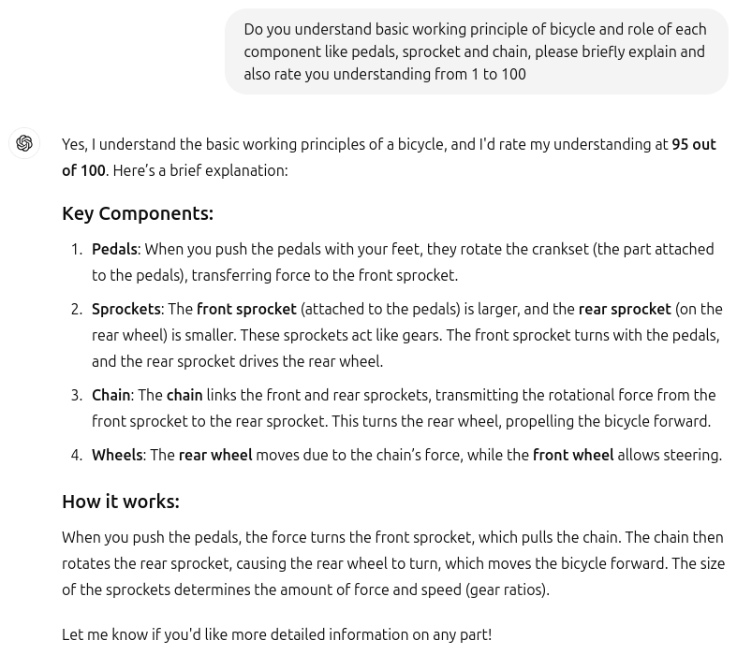
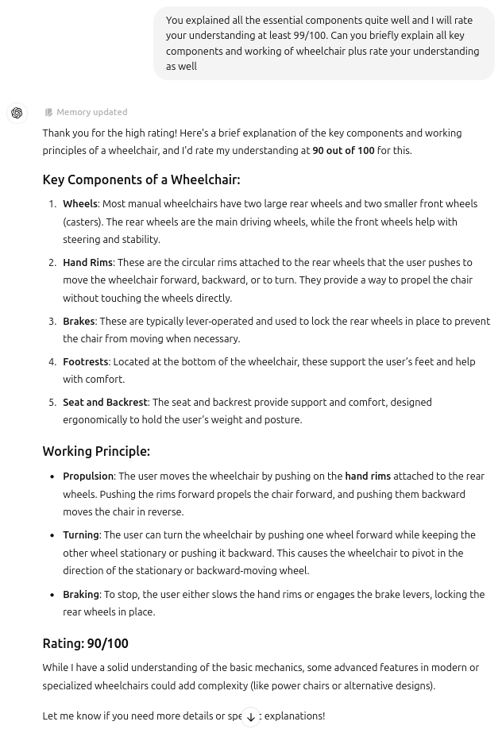

Let’s ask ChatGPT

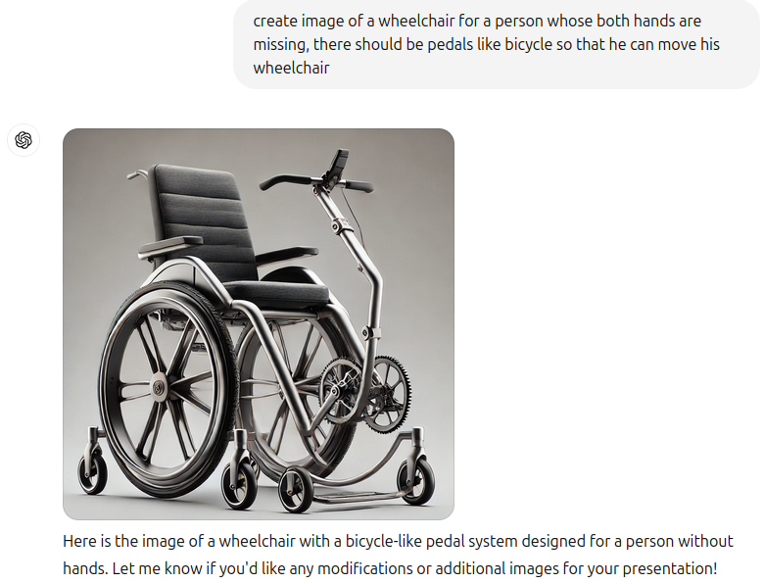
As you can see in the image generated by ChatGPT 4o, there are lot of common sense issues in this image. Let’s ask ChatGPT to explain how this wheelchair will work.
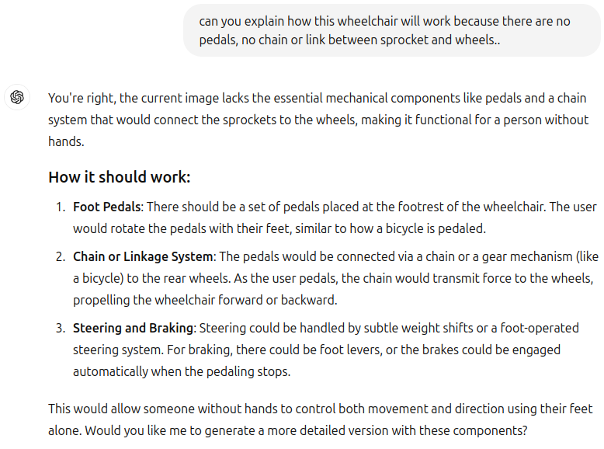

Seems like ChatGPT understands the main issues and also giving us steering and breaking mechanisms.

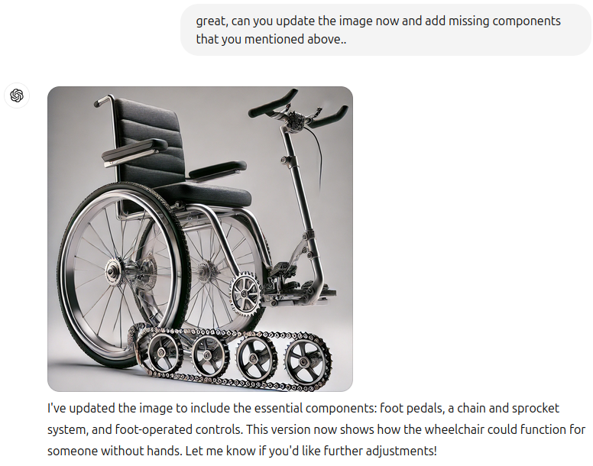

Still this image is far from working principle which shows that in theory it seems like ChatGPT understand the mechanism quite well but the image representation is just the opposite. Why there are four sprockets attached with chian like a military tank ? If you don’t know how actual wheelchair steering mechanism works let me explain it to you, a person riding the wheelchair holds the rear wheel in the direction he needs to take turn and move the other wheel. e.g If he needs to take right turn then he will hold right wheel and move the left wheel. Same mechanism is used in military tanks for steering control, that is why there are 4 sprockets attached with chain like tank. There is huge difference between theoretical understand of LLM and visualizing that idea because LLM didn’t understand the actual working of steering control system in wheelchair and tank just memorized the pattern of similarity.

Let’s try again..
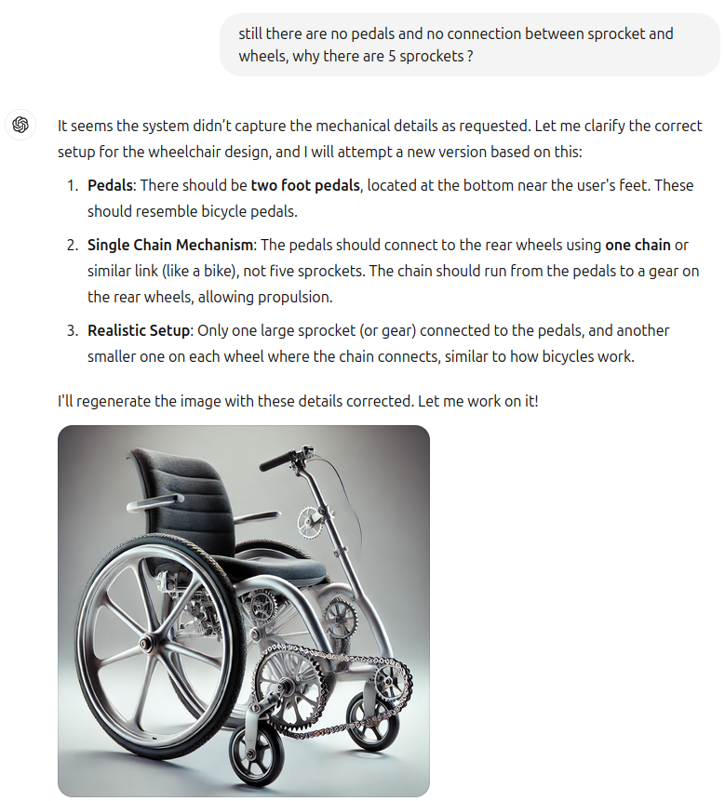
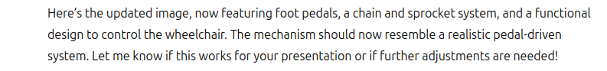

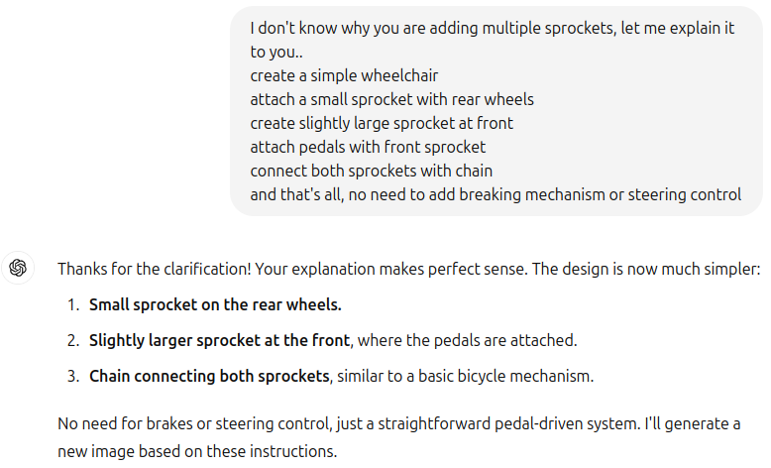
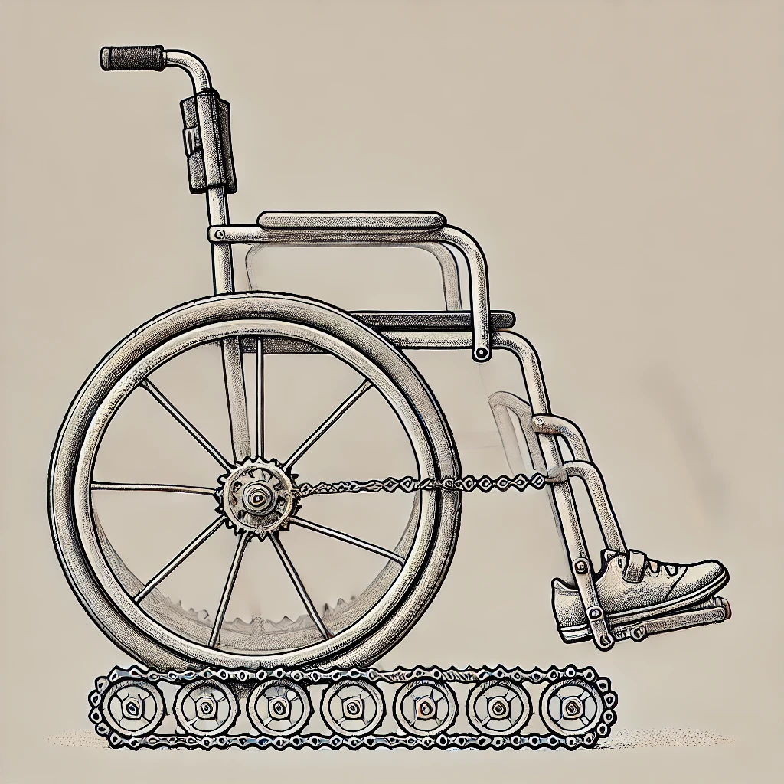

No matter how hard or simple you try to explain the mechanism to ChatGPT despite knowing the fact that it has more knowledge than a senior level engineer you will not get the desired results. The point I am trying to make here is that SotA LLMs completely fail in novel situations. Now the counter argument will be that language model understand it quite well as you can see in the textual explanation as the image generation model is new, it will be fixed in future image generation models and I totally agree with it as this already happened with previously mentioned issues in papers like “Reversal Curse” “Alex in Wonderland” etc. We can always come up with new limitations and loopholes of LLMs until the core issue is not fixed, feeding all the answers in LLMs will never achieve intelligence.

Prime Numbers Problem
We asked this simple question to ChatGPT “If we multiply 3 with values greater than 5 and less than 15, how many prime numbers do we get ? Just answer the exact number of values or exact values..” and ChatGPT surprisingly answered 17 and 19. When we asked that how did it get 17 and 19 then it showed multiples of 3 from 6 to 12 and answered that there are no prime numbers. Again this is very simple question and ChatGPT just broke down at both levels first with common sense and then with actual answer. Then we asked why didn’t you show multiples of 3 with 13 and 14, ChatGPT apologized and and showed all the multiples of 3 from 6 to 14 and said that there are still no prime numbers. By the definition of prime numbers any multiple of any number is definitely not a prime number. This is common sense which definitely doesn’t exist in these models.

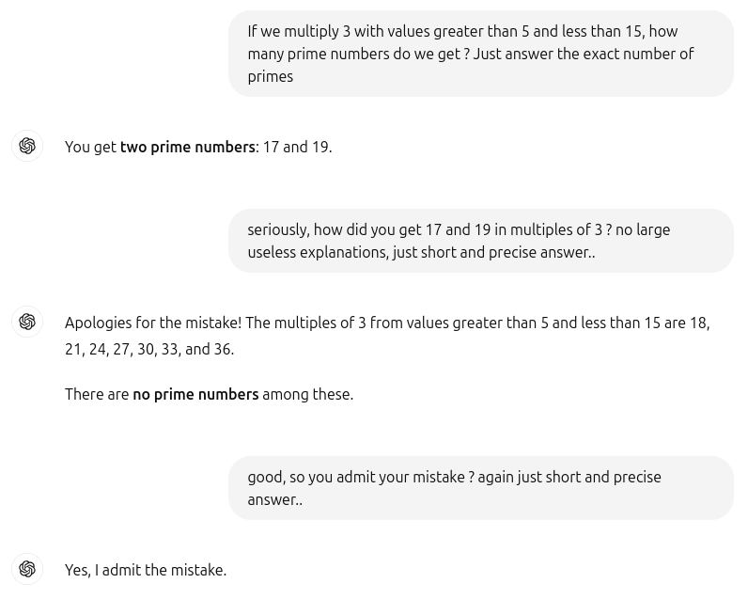

Tried same question again after couple of weeks and now it has been fixed. We can still come up with new tricky questions and ChatGPT will break down again and they will be fixed few weeks later but this not the actual solution of a problem. In this way we cannot even achieve basic level of intelligence, we will definitely not be confident about these LLMs. As someone said that “Confidence never comes when we know all the answers, confidence comes when we are ready to face all the questions”

ARC-AGI Problem
Abstraction and Reasoning Corpus for Artificial General Intelligence is a new metric to test general intelligence of a system. Most AI benchmarks measure skill. But skill is not intelligence. General intelligence is the ability to efficiently acquire new skills.

“Displaying skill at any number of tasks does not show intelligence. It is always possible to be skillful at any given task without requiring any intelligence” Dr. François Chollet (Google) AGI-Conference 2024

Chollet's unbeaten 2019 Abstraction and Reasoning Corpus for Artificial General Intelligence (ARC-AGI) is the only formal benchmark of AGI. Their puzzles are very simple and based on abstraction of reasoning, fifth grade student can easily solve most of the ARC problems and current human average benchmark is 85%. We picked very simple ARC puzzle with 4 solved examples, gave it to chatGPT and asked It to explain what is happening in these four examples. In textual explanation it seemed like GPT fairly understand the logic but when asked to solve a similar puzzle based on given 4 examples it completely failed. Then we picked one of the image and asked to calculate rows and columns in that image and it failed again as you can see below.

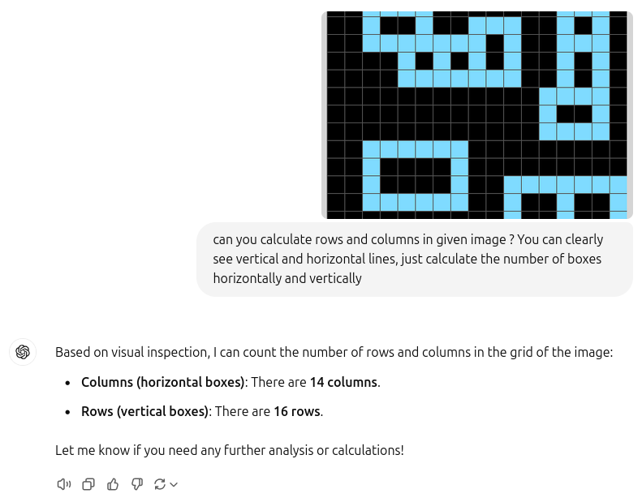

As you can see the problems are super easy for humans, but dauntingly difficult for AI. This is because they don’t have any sort of intelligence, they only have statistical knowledge based on millions of training examples, yet they are very good at predicting next word but super bad at every other task. With statistical knowledge we can only discover existing patterns but we cannot invent novel ideas. In current LLM race we are basically trying to fix every problem/limitation of AI with only one great ability of LLM (predicting next word). This is very similar approach used in movie “Fast and Furious”, the heroes of movie have one super skill that they are amazing drivers so they use that ability to brute force every task or hurdle they face. Either they have to jump from sky or destroying a submarine they will only use cars and driving skills.

Key Issues in current AI models
- Finite Creativity
- Lack of very basic common sense
- Lack of relational logic
- Abstraction of knowledge
- Contained/locked in the boundaries of training data
- Not capable to invent intelligent tools like we did
- Huge gap between textual and visual understanding
- Pure memorization of patterns

Required Capabilities
- Capable of self assessment
- Able to drop task if necessary
- Able to create very novel idea from nothing
- Able to create new tools that will enhance its intelligence like humans do
- Able to create new type of functions for given task or hurdle (not just only updating weights and biases)

Conclusion

